# Question(1)

## Q(a)

Download and load dataset.

Normalized images data into [0,1] and split **10000** of 60000 of the whole train datasets as validation dataset.

The final size of train and validation is **50000, 10000.**

Since kmnist dataset size is **28 * 28** and only 1 channel(greyscale), the input shape is **28*28*1**.

## Q(b)

Build an ANN with input layer and 2 hidden layers.

Flatten input image in input layer.

Add two hidden layers with **256** and **128** neurons, each hidden layer utilizes **relu** as activation function, and each layer add **BatchNormalization** and **Dropout** to prevent overfit.

## Q(c)

Add output layer with **10** neurons with **softmax** as activation function.

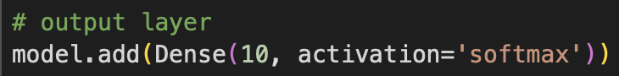

Each neuron represents one class of classifier.

The **softmax** activation function is ideal for multi-class classification problems, since the sum of output after transformed by softmax is 1, and each output is between [0,1], it can represent the probability of predicting each class.

## Q(d)

Utilize **SparseCategoricalCrossentropy** as loss function. Because the labels are integers between [0,9], not one-hot format.

As for optimizer, used **Adam** and **RMSprop**.

**Adam** combines the benefits of **AdaGrad** and **RMSprop** by using running averages of both the gradients (first moment) and the squared gradients (second moment). This results in individual adaptive learning rates for different parameters.

**RMSprop** maintains a moving average of the squared gradients to adjust the learning rate for each parameter.

From the result on test dataset, we can see that **RMSprop** has outperformed **Adam** slightly, achieving a test accuracy of 89.40% compared to Adam’s 88.72%. However, the differences are not substantial, indicating both optimizers are effective for this problem.

## Q(e)

Code for plotting.

Result:

From plot we can see that losses of both validation and training are decreasing with number of epochs, which means no overfitting.

## Q(f)

Code snippets:

Result:

We can see that model’s prediction on all classes are above 87% which means the model is well generalization.

Classes 3 ,6 and 8 have particularly high accuracy (95% ,94% and 92% respectively), indicating the model performs very well on these three classes.

Class 1 and Class 9 have a moderate number of misclassifications with other classes comparing to other classes.

# Question(2)

## Q(A)

Initialization of environment

Class **GridWorld** initialize with grid size(default=5),start state(0,0),goal state(4,4) and obstacles(2,2),(3,3). And actions U,D,L,R represent move of agent.

Step function calculate the next state, reward/penalty and whether agent finish episode.

Left is the visualization of Grid.

## Q(B)

1.The size of Q-table should be (number of state) * (number of actions), in this case, It’s 5*5*4.All values are initialized as 0.



2.a Exploration strategy

2.b Learning rate and discount factor

2.c Update rule for Q values

To be more specific:

New_Q = Old_Q + alpha [reward + gamma(max(value of next state)) – Old_Q]

3.Code for training:

Training log:

Both episode and total steps are recorded.

Code for plot:

Plot of cumulative reward:

## Q(C)

Code for experiment and plot:

Following are the policies in different parameters:

Baseline model Higher alpha

Lower discount factor Higher exploration rate

So for different parameters:

1. Higher alpha: The agent learns faster and may exhibit more aggressive policy updates.
2. Lower discount factor: The agent focuses more on immediate rewards.
3. Higher exploration rate: The policy is more varied and can capture a wider range of possible strategies.

To conclude:

Learning Rate (alpha): Determines the size of updates to Q-values; higher α results in faster but potentially less stable learning, while lower α leads to slower but more stable learning.

Discount Factor (gamma): Controls the importance of future rewards; higher γ values make the agent prioritize long-term gains, while lower γ values make it focus more on immediate rewards.

Exploration Rate (epsilon): Balances exploration and exploitation; higher ε values encourage more exploration of the environment, while lower ε values favor exploiting known information.

## Q(D)

Code:

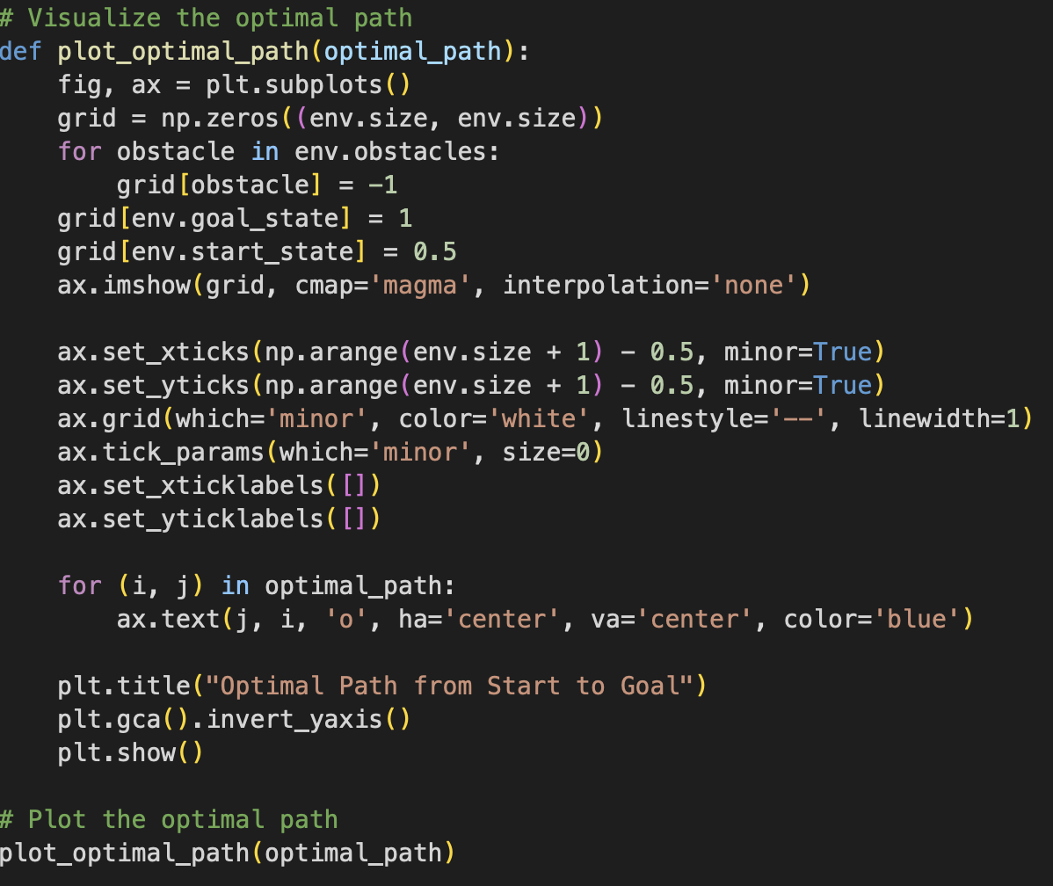

Result:

